Batch: 4
Roll No.: 16010123012

Experiment / Assignment / Tutorial No.: 03

TITLE: Introduction to Power BI
Objective:
To introduce the fundamentals of Power BI and enable students to create basic interactive visualizations using data.
_________________________________________________________________________
Expected outcome of Experiment:
CO1 | Learn how to locate and download datasets, extract insights from that data and present their findings in a variety of different formats.
_______________________________________________________________
Books/ Journals/ Websites referred:
https://learn.microsoft.com/en-us/power-bi/create-reports/desktop-excel-stunning-report
_____________________________________________________________________
Background Theory:

Power BI is a Microsoft business analytics tool that transforms raw data into interactive, visually rich reports and dashboards, helping users discover insights, track trends, and make data-driven decisions. It connects to numerous data sources, offers user-friendly drag-and-drop features for visualization.

Laboratory Work:

Refer this link:
https://learn.microsoft.com/en-us/power-bi/create-reports/desktop-excel-stunning-report

Perform these tasks
- Connecting to Data Source and Visualizing one specific table
- Creating and refining a view
- Focus results
- Exploring data geographically
- Drill down into the details

**Practice these tasks for Financials (default dataset available in Power BI) and one more dataset like Customer Profiling dataset

Implementation screenshots:
Financials:
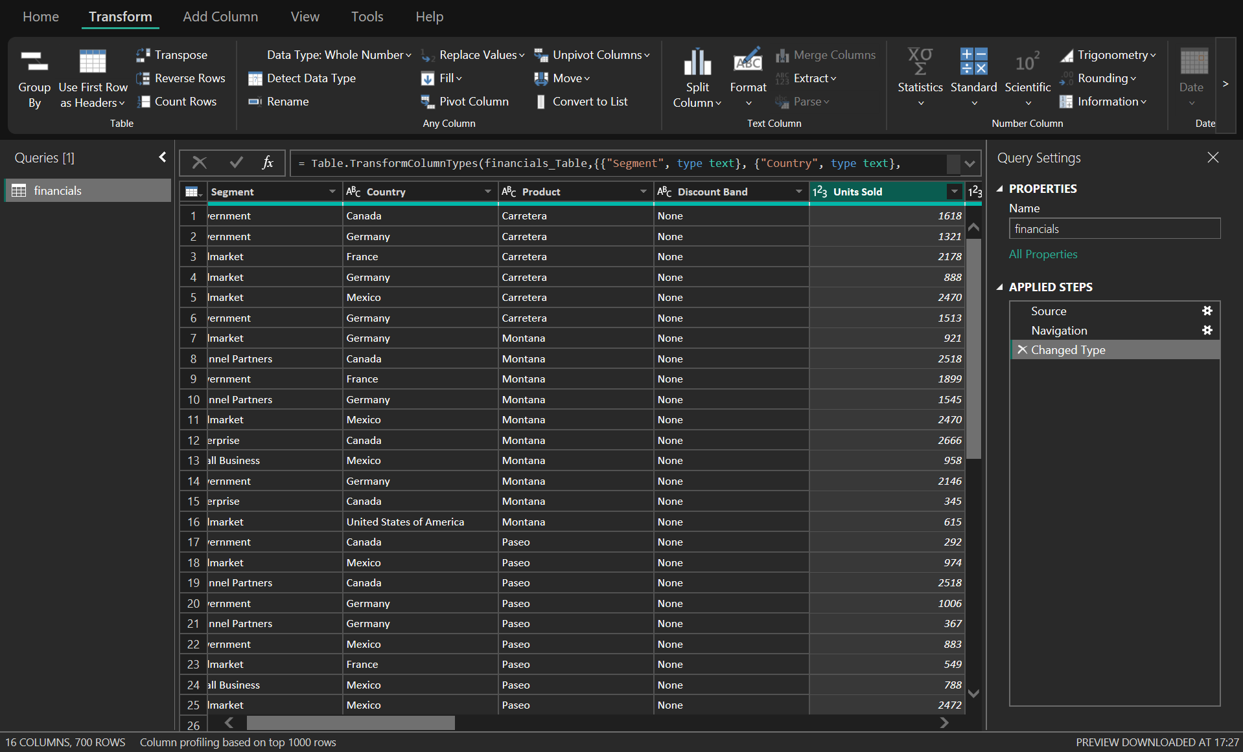
Changed Type
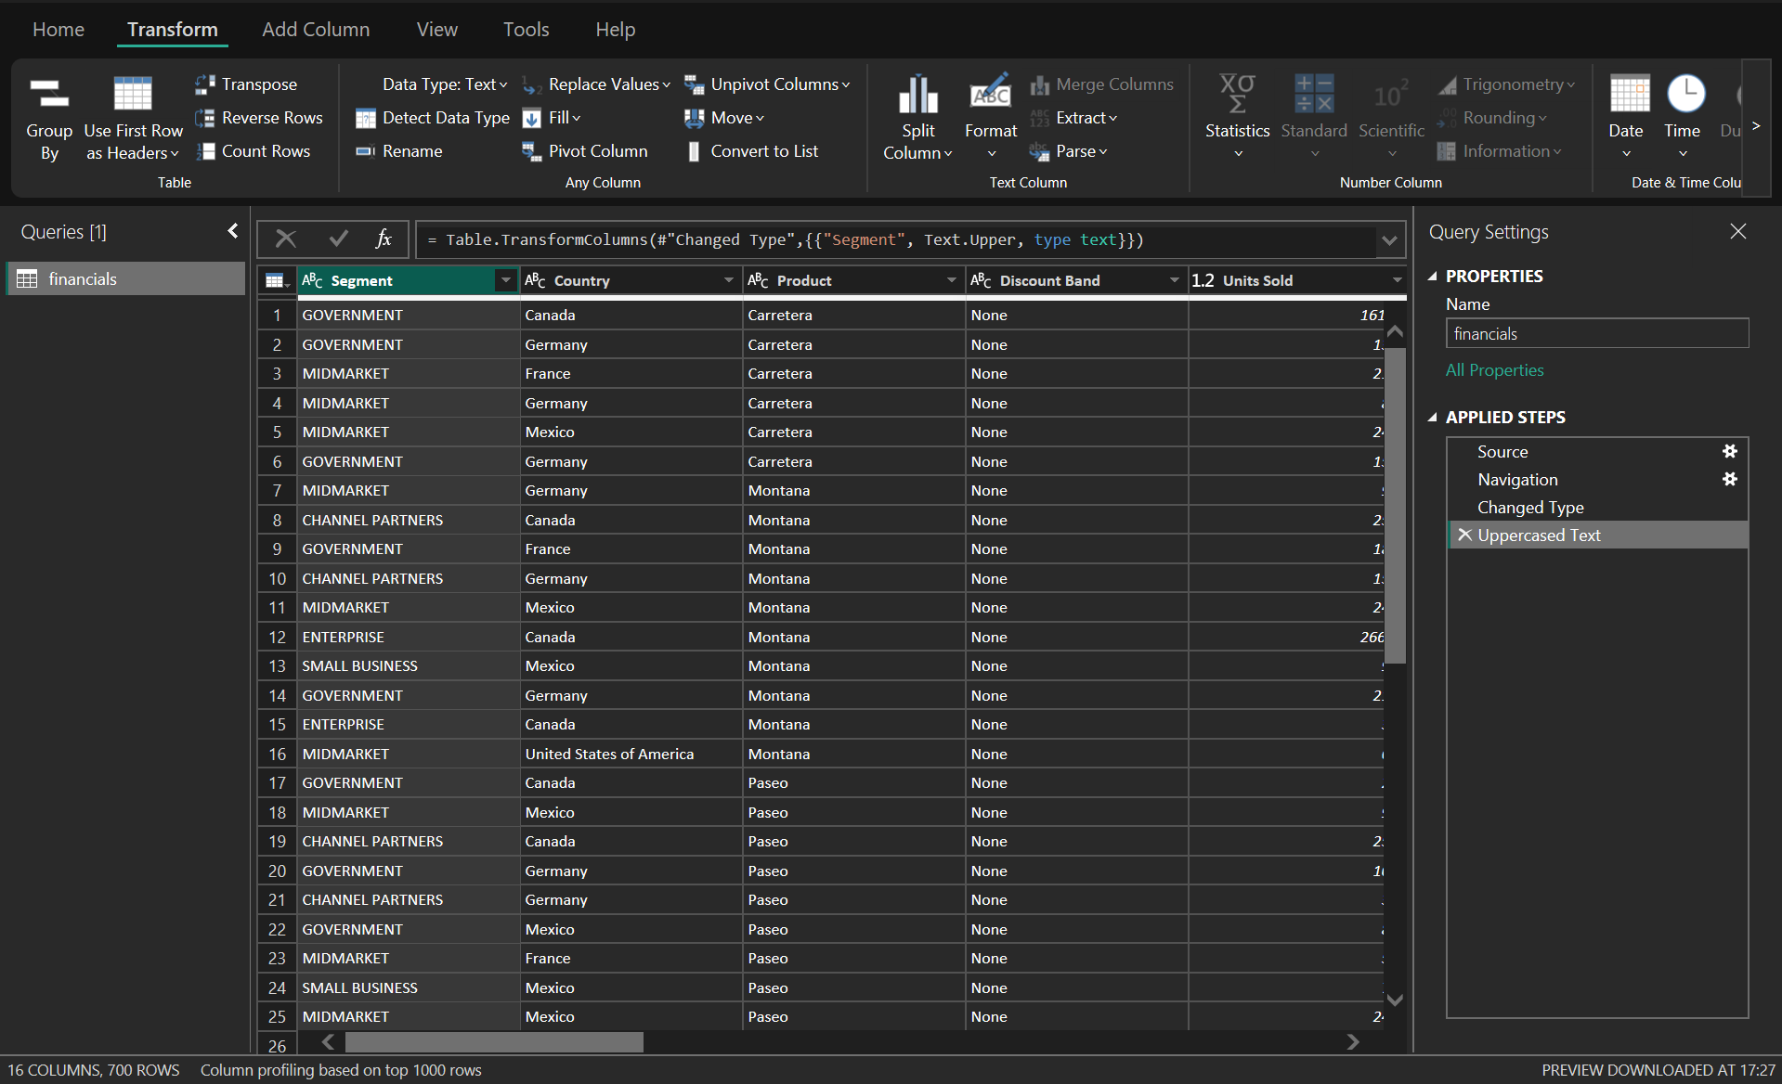
Uppercased Text
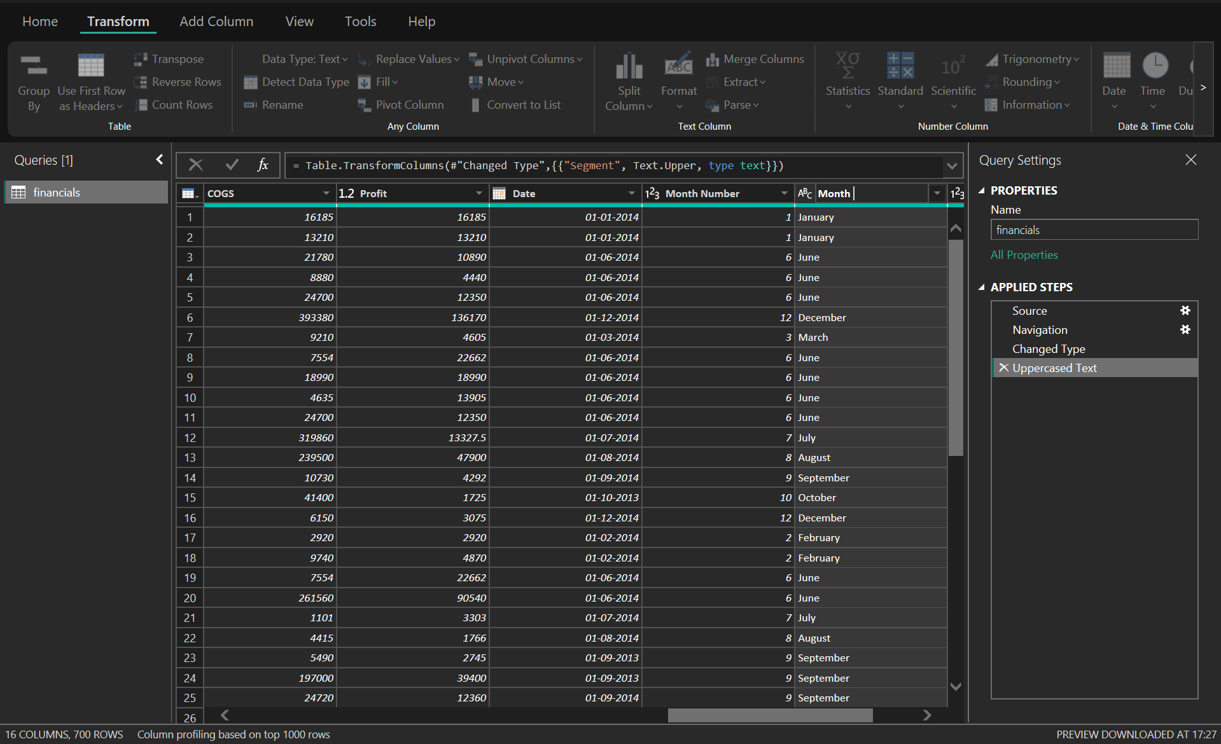
Renamed Columns
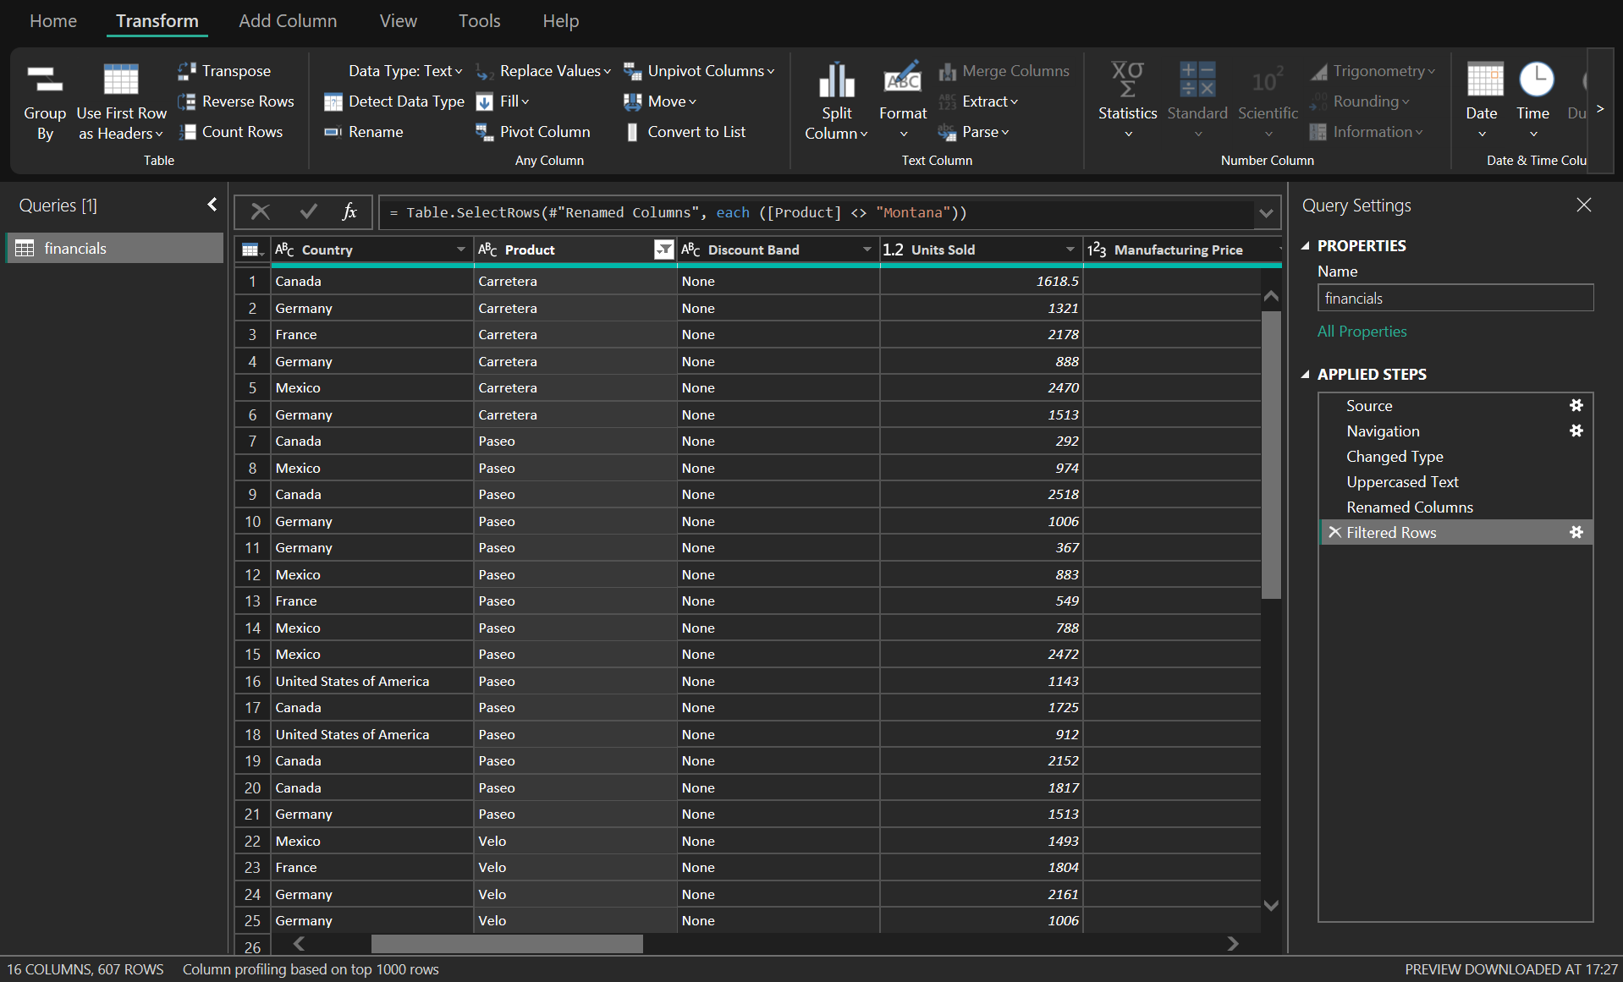
Filtered Rows

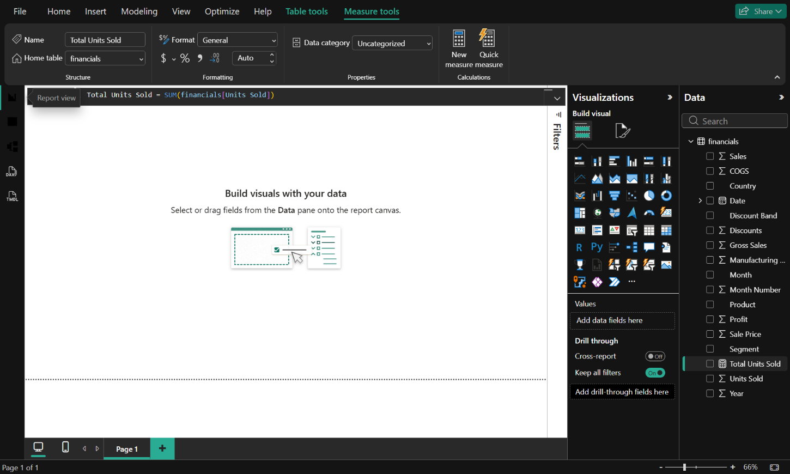
Visualization
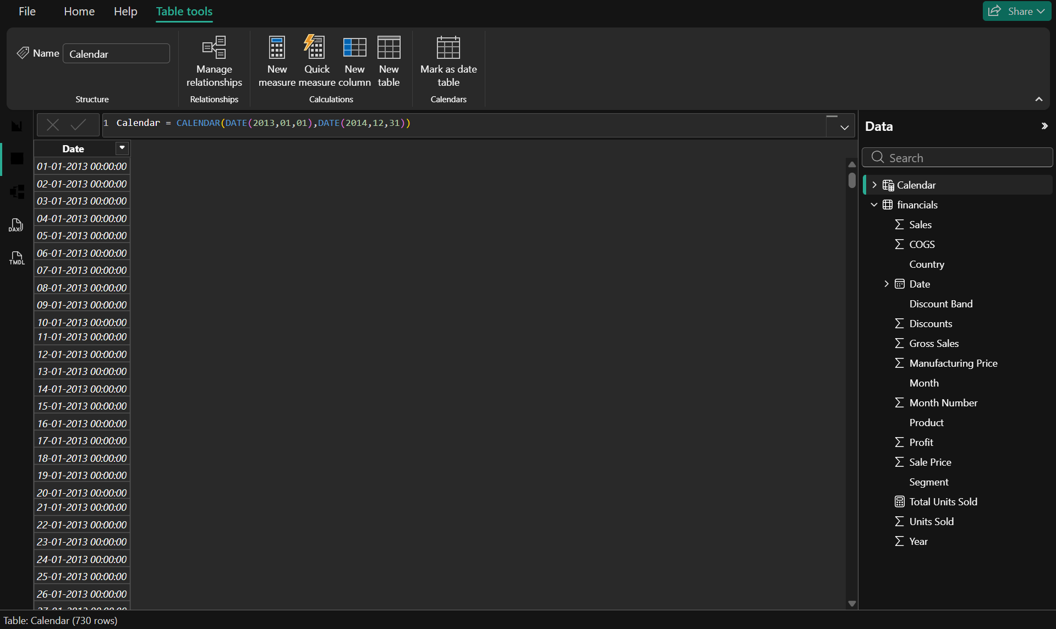
Created a New Measure

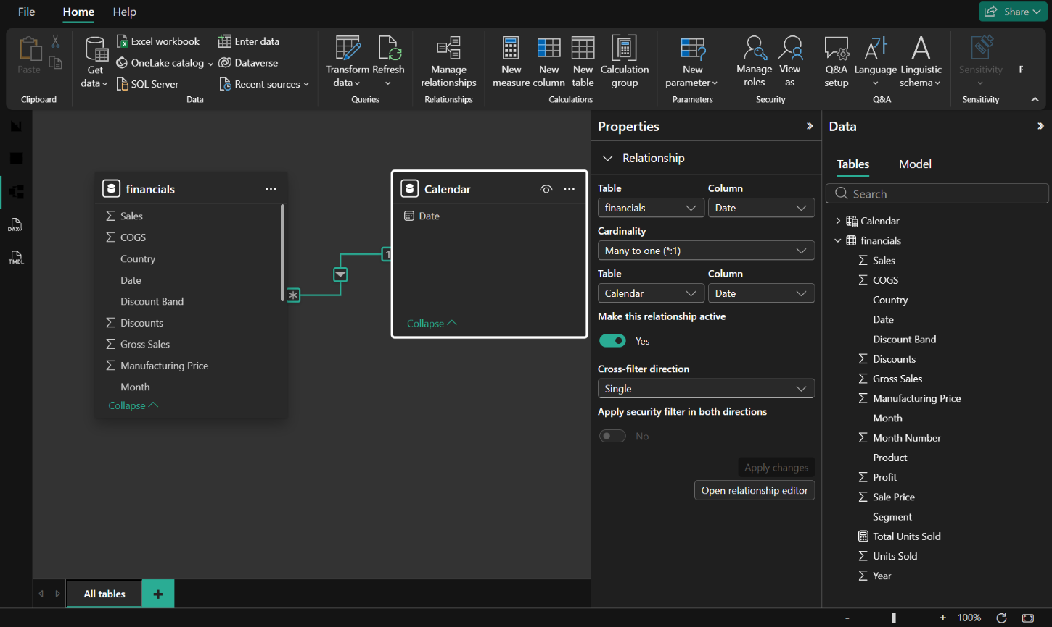
Created a Relationship for the New Measure
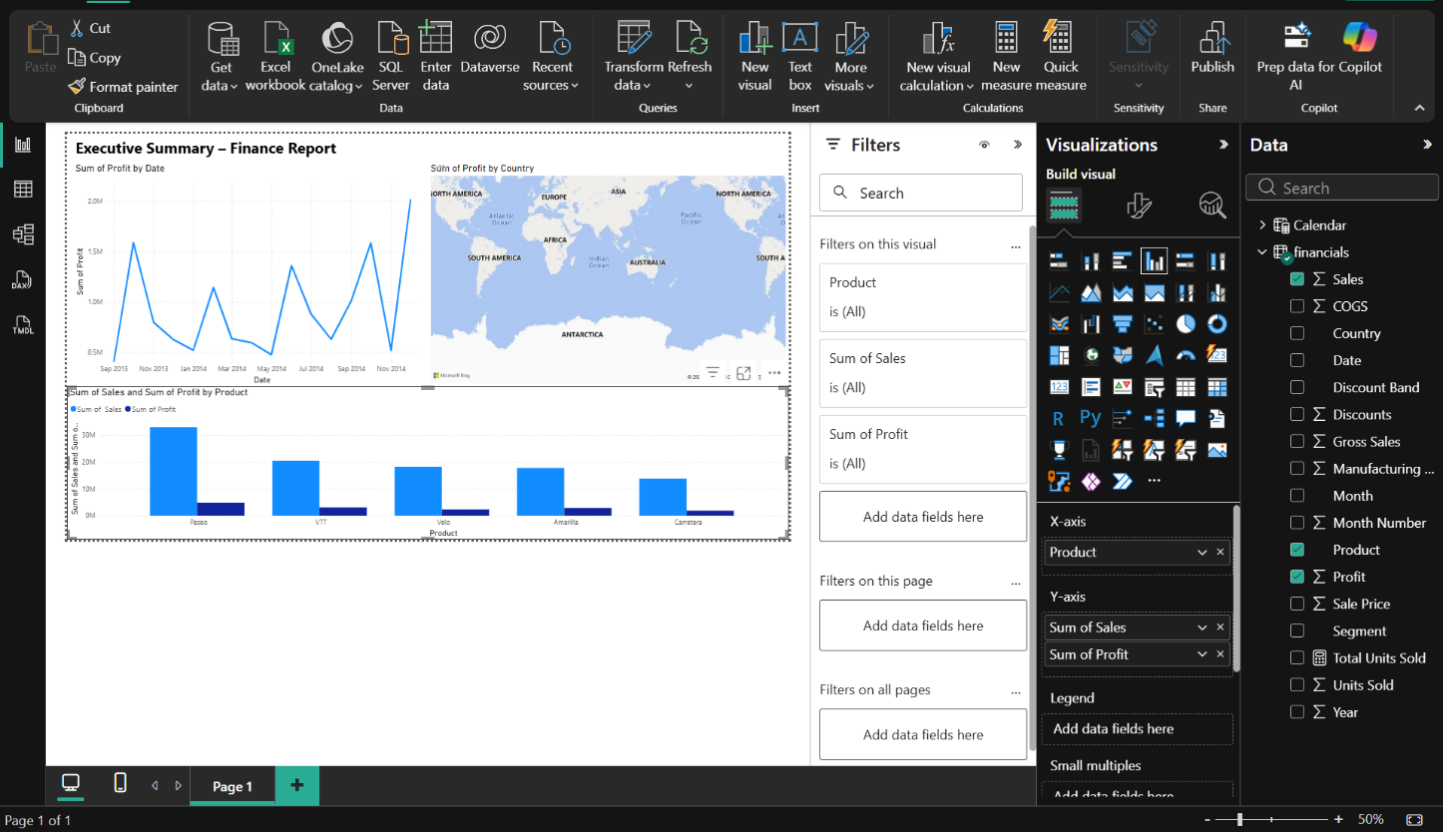Building a Report

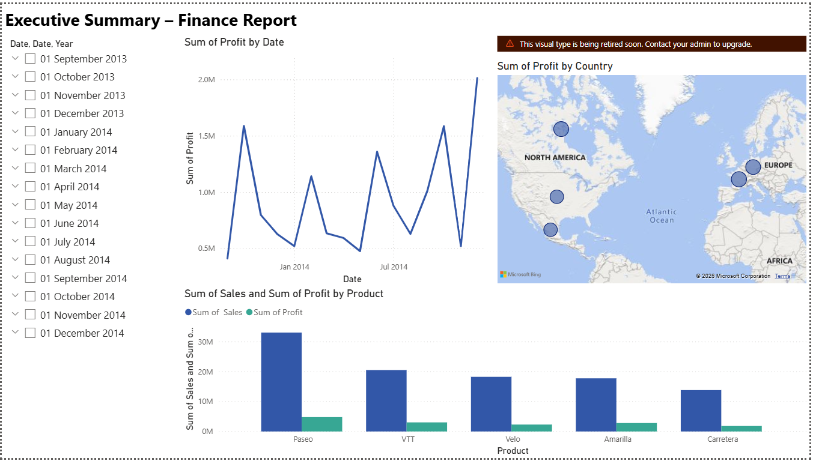Final Report

Marketing:
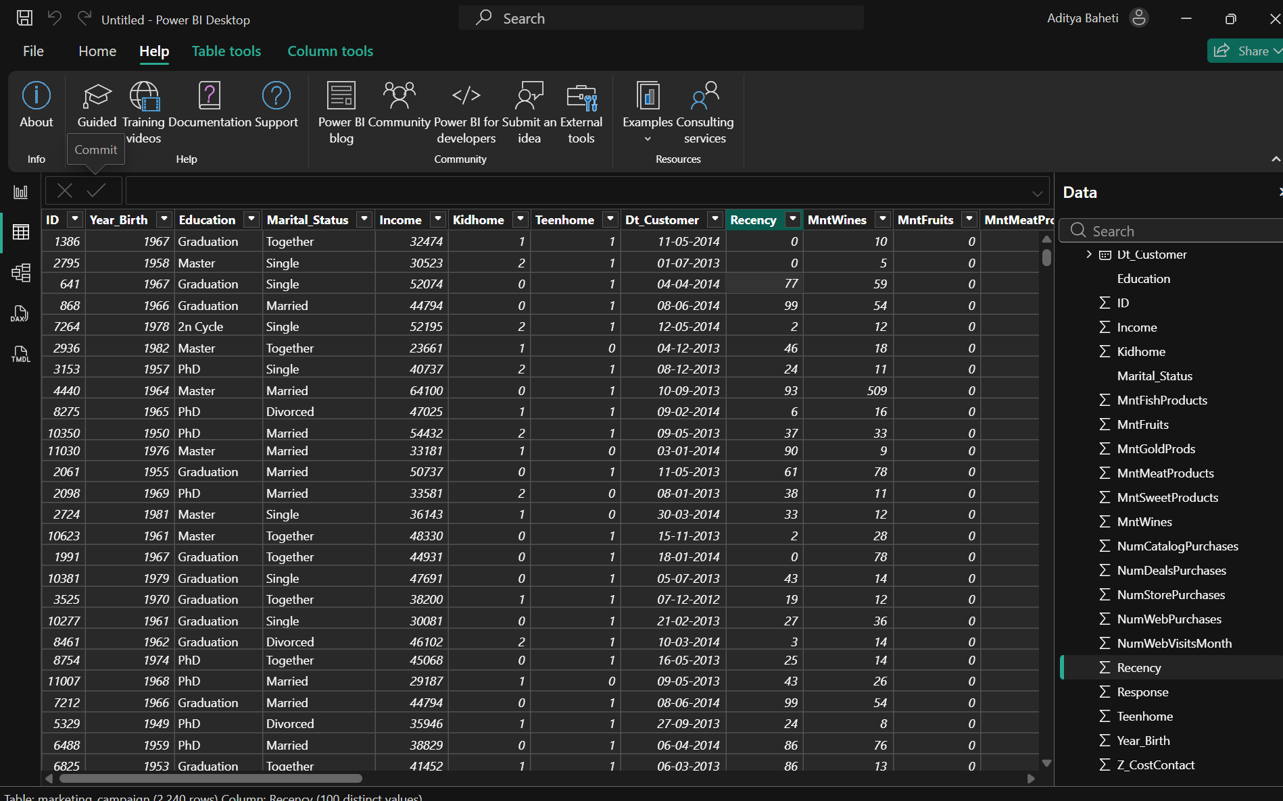
Changed Type
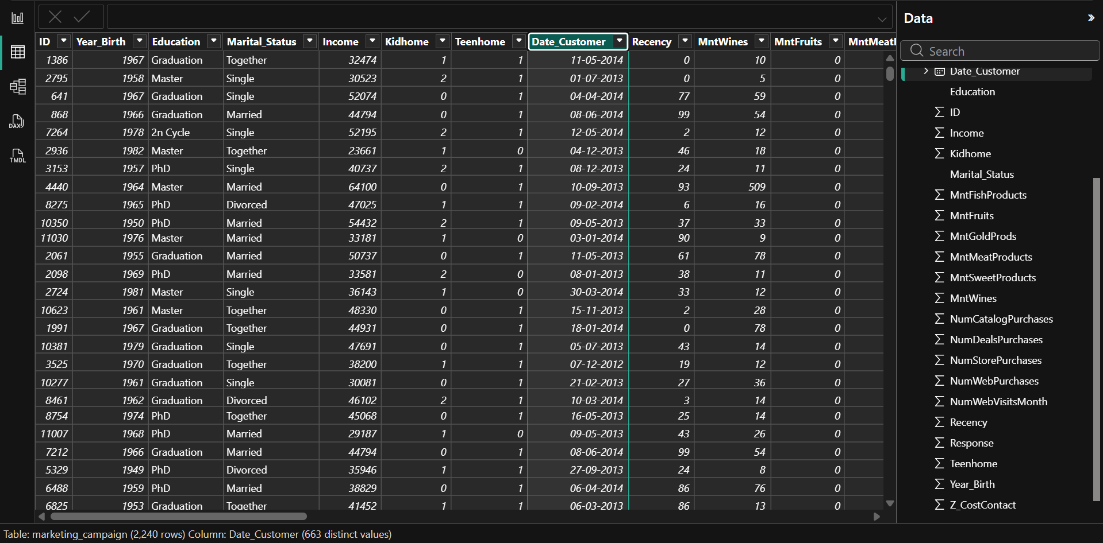Changed Name
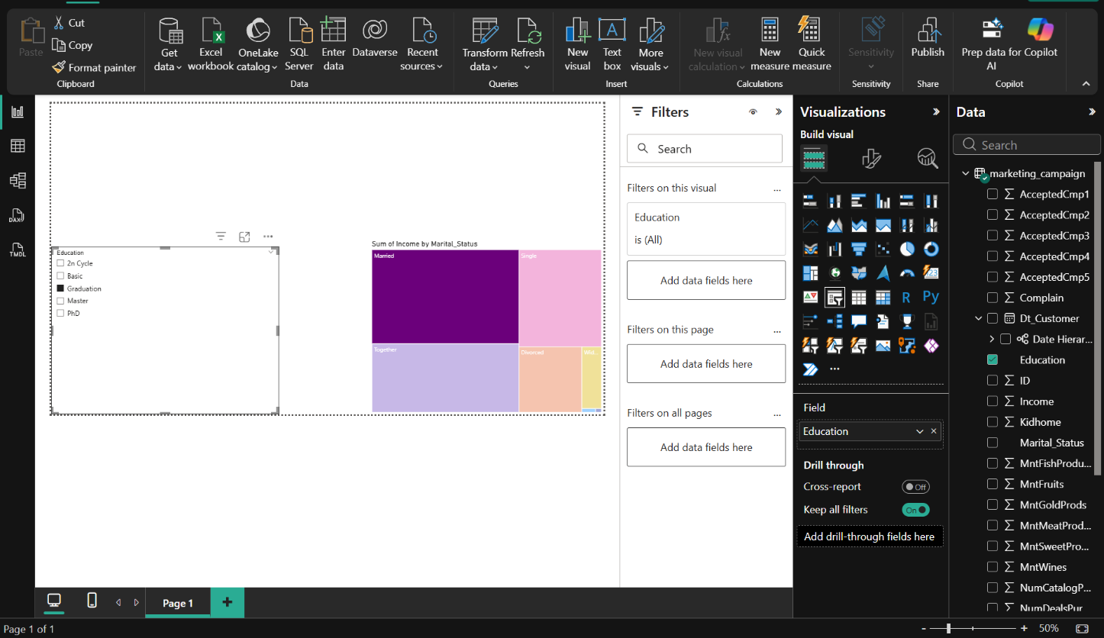
Creating using Slicer Mode

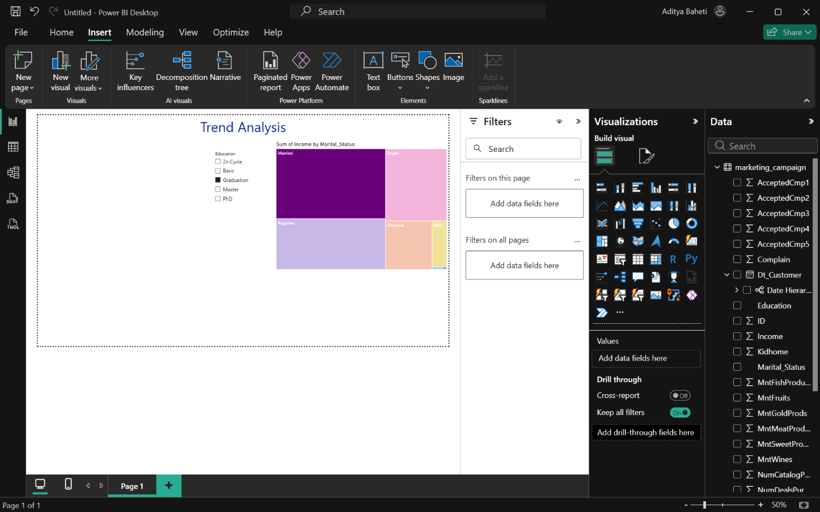
Added Text to Report
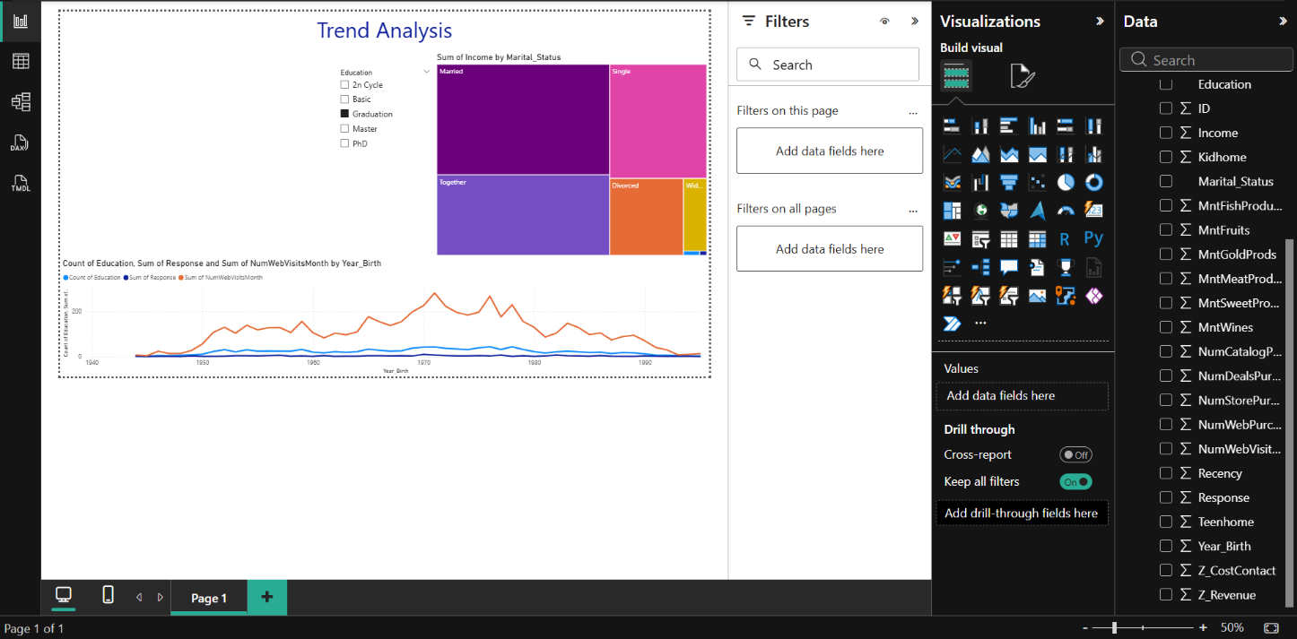Added Line Chart

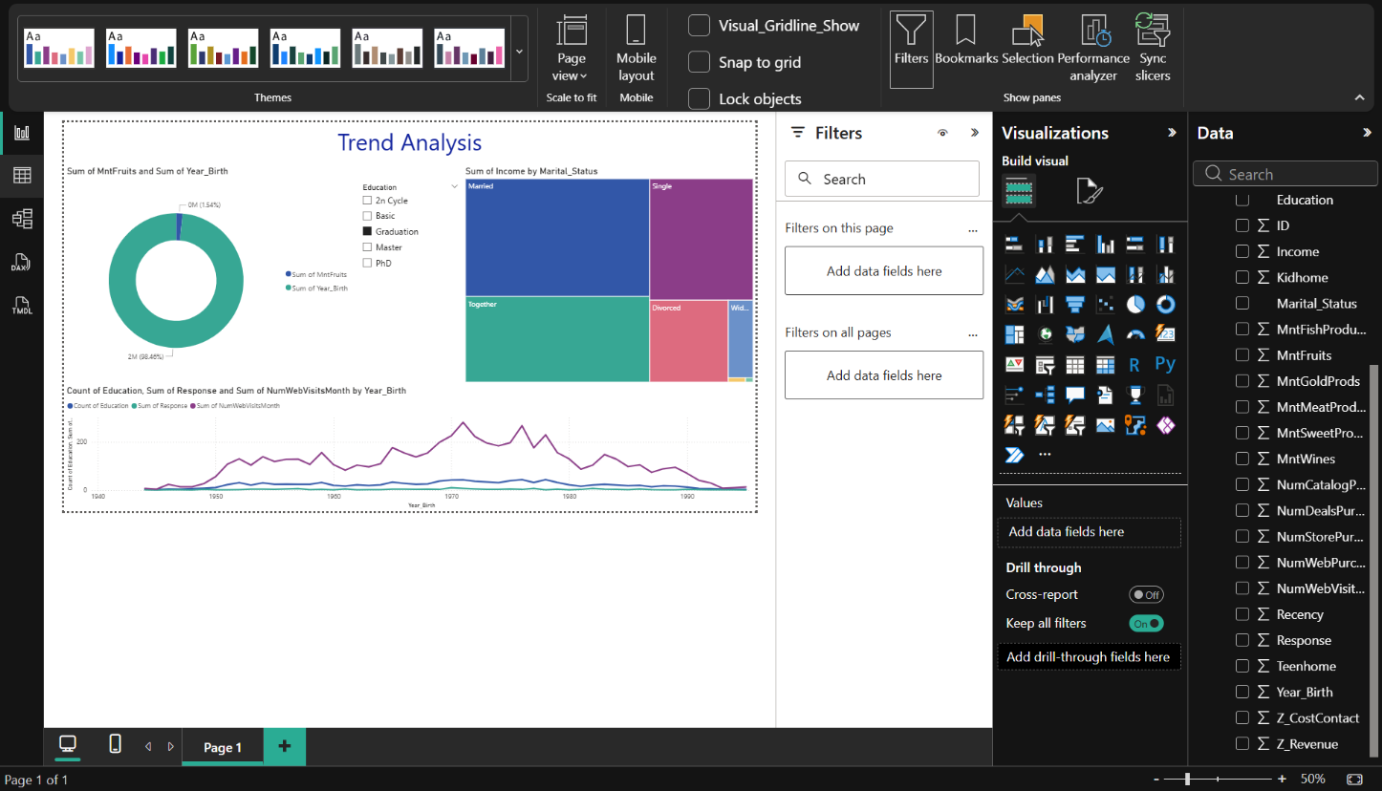Added Donut Chart
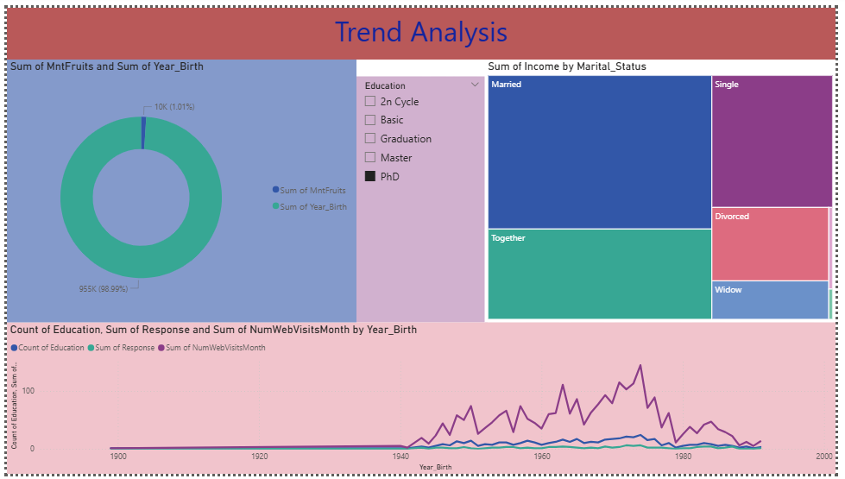
Changed Format Settings

Conclusion:
This experiment successfully introduced the fundamentals of Power BI and demonstrated how raw datasets can be transformed into meaningful visual insights. By connecting to different data sources, cleaning and transforming data, creating relationships, and building interactive reports, the practical illustrated the complete workflow of data visualization. Various charts such as line charts, donut charts, maps, and slicers were used to analyze Financial and Marketing datasets. The experiment enhanced understanding of data preparation, measure creation, and report design, enabling effective presentation of trends and patterns. Overall, the objective of learning dataset handling and developing interactive dashboards using Power BI was achieved, fulfilling the expected course outcome.
Post Laboratory Questions
- Which tool inside Power BI is used to connect to, clean, and transform data before you start building charts?
Power Query Editor is the tool used in Power BI to connect to data sources and perform data cleaning, shaping, and transformation operations. It allows users to remove unwanted columns, change data types, filter rows, rename fields, and prepare datasets before loading them into the Power BI model for visualization.
- In Power BI, what is the specific language used to write formulas and create custom calculations (like measures and calculated columns)?
DAX (Data Analysis Expressions) is the formula language used in Power BI to create calculated columns, measures, and custom aggregations. DAX enables users to perform advanced calculations such as totals, averages, time-based comparisons, and business logic directly within reports.
- If you want to show how your Sales have increased or decreased over the last 12 months, which chart type is the standard choice?
A Line Chart is the standard visualization used to represent changes over time, such as sales growth or decline over the last 12 months. Line charts clearly display trends, making it easy to identify patterns, peaks, and drops in performance.
- Your data includes a column for "City" and "Country." Which visual type would automatically plot this data onto a world or regional background?
The Map visual automatically plots geographic fields like City and Country onto a world or regional map. This visual helps analyze location-based data by displaying values geographically, making regional comparisons intuitive and visually clear.

